Scottish Food Coalition – 1 page overview of food system problems

Further resources are available here.
If you have any questions then just drop us an email at info@foodcoalition.scot

What is the Scottish Food Coalition? The Scottish Food Coalition (SFC) is a network of organisations who campaign to transform our food system. Separately, members of SFC work on issues ranging from workers' rights to protecting nature, tackling diet-related ill-health and food poverty. SFC was formed with the acknowledgement that these different food related challenges are in fact, all interrelated and can be tackled more effectively if we address them together. See who our coalition members are, find out more about what we do, and how we operate.

Facts about the food system. Why we campaign to transform it

The issue | Statistics | Further reading
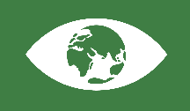  Food, nature and the environment | - In Scotland, farming is responsible for nearly a quarter of our greenhouse emissions, the third largest source of emissions (Farming for 1.5C).  - Food and agricultural production are the main drivers of global biodiversity loss. In Scotland, nature is changing rapidly with 62% of species showing strong changes (up from 45% 10 years ago). (The State of Nature Scotland  - 46% of fresh food sold in the UK contains pesticide residues. (Source: Nourish Scotland Food Atlas) | - Farming for 1.5C (Nourish Scotland, Nov 2020)  - State of Nature 2020 (RSPB)  - From Farm to Fork (EU Strategy report)
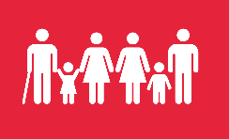  Food and poverty | - For women, obesity rates in 2019 were 40% in the most deprived areas compared to 18% in the least deprived areas. In under 15s, the gap between rates in the most and least deprived areas was 15% in 2019. Source: ScotGovPublications: Diet and healthy weight Report 2020  - Adults and children in the lowest income decile eat 42% less fruit and vegetables than recommended. Source: UK National Food Strategy | - Food in Scotland Consumer tracker survey (Food Standards Scotland, 2020)
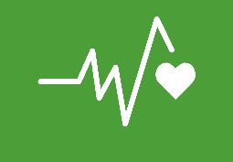  Food and health | - People with diet-related diseases are almost as much at risk of dying from Covid as people with cancer and older people: Between March and May 2020, over 18,000 Covid deaths were people with diet-related diseases (obesity, diabetes and hypertension).  - Over ¾ of food products sold in the UK in 2018 were ‘unhealthy’ because they are highly-processed, made with cheap ingredients – fats, sugars, flour. Source: UK National Food Strategy | - Diet and healthy weight: Monitoring Report 2020 (Scottish Government Publications, 2020)  - Force-Fed (The Food Foundation, 2015)
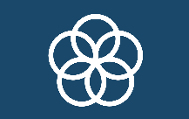  Food and jobs | - Nearly half of food sector employees have too little in savings to be able to withstand a 20% loss of income for 3 months (the effect of going onto furlough). Yet, since lockdown, nearly 73% of employees in the hospitality sector, more than any other sector, were furloughed. Source: UK National Food Strategy  - 64% of accommodation & food service workers and 25% in agriculture, forestry & fishing earn below a Real Living Wage Source: ScottParliament Research Briefings | - The good food economy (Sustain website)  - Scotland Food & Drink Recovery Plan
Further general reading:
Plenty - Food, farming and health in a new Scotland (SFC 2016) sets out what a different food system could look like, why we cannot continue business as usual, and where we should start on transforming it. It shows that the focus should be on: valuing people, prioritising environmental sustainability, recognising that food is critical to health and well-being; and on building on short supply chains that generate wider community benefits.

Nourish Scotland Food Atlas (Nourish Scotland, 2018) maps out a dozen elements of Scotland’s food system in eye-catching infographics. For each topic, it shows what a more sustainable food future might look like in 2030; how we can get there; and what is already happening (a case study). There are 13 double-pages, each about Our … land, seas, bees, soil, bread, waste, cows, the Right to Food, and more.

