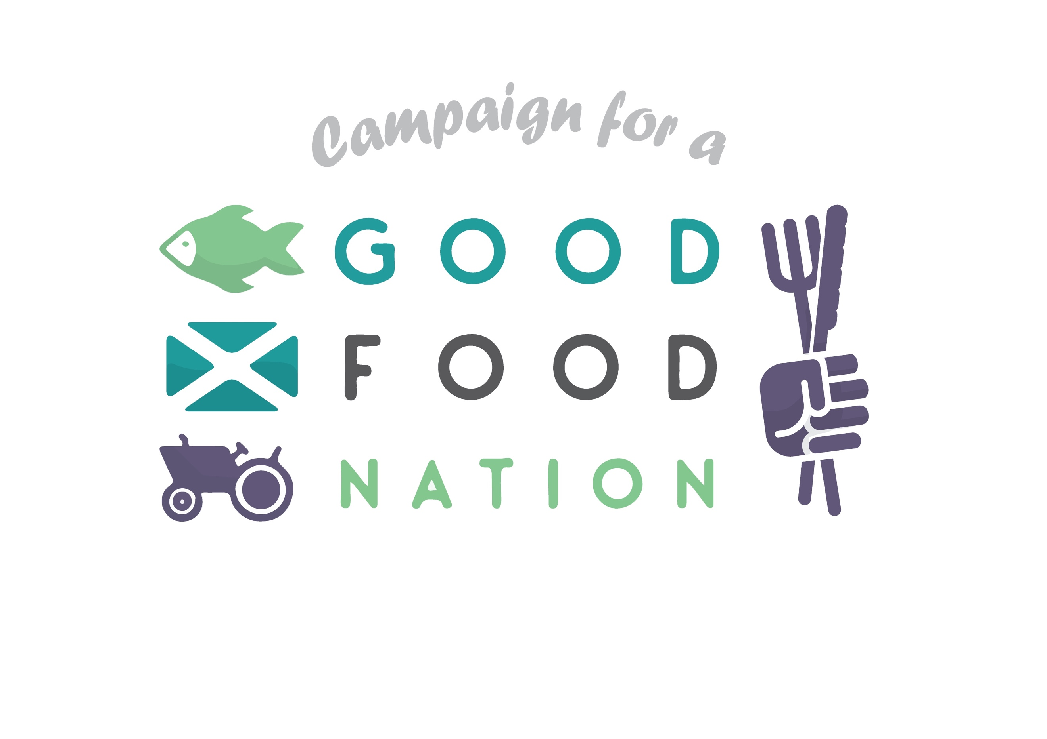

Good Food Nation Ambassador: Volunteering Agreement

We really value the time and skills volunteers bring to the Scottish Food Coalition and will do the best we can to make your volunteer experience with us enjoyable and rewarding.

This agreement outlines what you can expect whilst volunteering at the Scottish Food Coalition – a supportive, safe and inclusive environment, and what we too expect from volunteers.

Volunteering Role

We think it’s important to be clear about the activities we could most use your support with.

The core role and activities:
- Support your local community to engage with the campaign for a healthier, fairer and more sustainable food system.
Examples of activities include:
- Organising workshops to support local people to answer consultations, helping to ‘debunk’ questions, and supporting people to get their voices heard.
- Working with existing local networks, with support from the Scottish Food Coalition, to publicise issues and recommendations locally, via social media, websites, press etc.
- Coordinating volunteer attendance to local MSP surgeries to discuss issues and recommendations relating to the Good Food Nation Bill
- Hosting a town hall-style meeting on the local food situation, with the aim of creating a list of issues and recommendations to deliver to constituency MSPs
- To promote support for Good Food Nation movement among local food-related practitioners by asking them to display the GFN logo (e.g. food outlets, GPs, dentists and community health workers, market-gardens and allotments, environmental campaign groups, farmers etc.)
Support and flexibility

- We will provide an induction on the work of the Scottish Food Coalition, the people involved, the organisational policies, your volunteering role and the background information you need to meet the responsibilities of this role.
- We will explain the standards we would like to achieve and encourage and support all our volunteers to achieve and maintain them.
- We will provide a named person who can meet with you to discuss your volunteering and any successes and problems. Your named person is: Stephanie and Diana
- We will do our best to help you develop your volunteering role with us.

Expenses

- We will repay out of pocket expenses including: travel and materials needed to complete volunteer activities.

Safe and Inclusive Space

- We will provide relevant training and feedback in support of our health and safety policy.
- We will provide adequate insurance cover for volunteers whilst undertaking voluntary work approved and authorised by us.
- We will ensure that volunteers are treated in accordance with our policies on equal opportunities, anti-harassment, bullying and victimisation, and data protection

Problems

- We will try to resolve fairly any problems, grievances and difficulties you may have while you volunteer with us and in the event of an unresolved problem will meet to discuss the issues.
- You should first discuss any problems with your named person if the problem concerns the named person.

The volunteer

We expect you:

- To help with the activities outlined in the volunteer role;
- To perform your volunteering role to the best of your ability;
- To follow the organisation’s policies, procedures and standards, including equal opportunities, anti-harassment, bullying and victimisation, data protection, and alcohol and drugs;
- To meet time commitments and to give reasonable notice if you are not able to attend so other arrangements can be made when this is not possible.

Whilst volunteering you are representing the Scottish Food Coalition. If you are approached with a question or query that goes beyond your volunteering role and activities pass it on to the named person.

Volunteering outputs remain the intellectual property of Scottish Food Coalition and will with your permission be referenced with your name.

